**LinqDataSource, ListView, DetailsView**

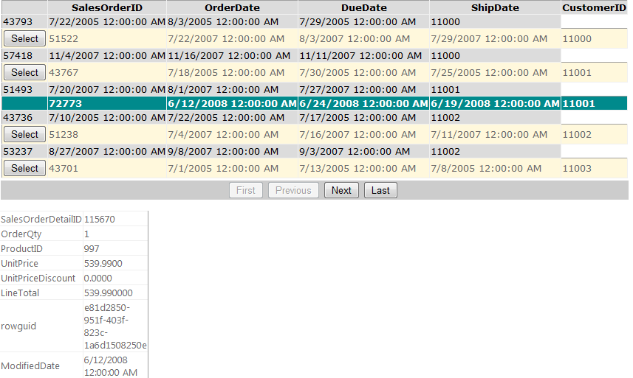

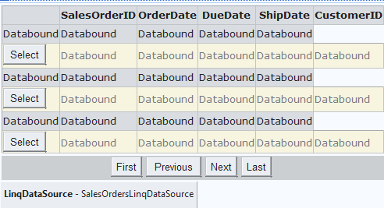

<h2>

Sales Orders

</h2>

<asp:Label ID="lblCategory" runat="server" Text=""></asp:Label>

<p>

|  |
| --- |
| <asp:ListView ID="SalesOrdersListView" runat="server" DataKeyNames="SalesOrderID DataSourceID="SalesOrdersLinqDataSource">  <AlternatingItemTemplate>  <tr style="background-color: #FFF8DC;">  <td>  <asp:Button ID="SelectButton" runat="server" Text="Select" CommandName="Select" />  </td>  <td>  <asp:Label ID="SalesOrderIDLabel" runat="server" Text='<%# Eval("SalesOrderID") %>' />  </td>  <td>  <asp:Label ID="OrderDateLabel" runat="server" Text='<%# Eval("OrderDate") %>' />  </td>  <td>  <asp:Label ID="DueDateLabel" runat="server" Text='<%# Eval("DueDate") %>' />  </td>  <td>  <asp:Label ID="ShipDateLabel" runat="server" Text='<%# Eval("ShipDate") %>' />  </td>  <td>  <asp:Label ID="CustomerIDLabel" runat="server" Text='<%# Eval("CustomerID") %>' />  </td>  </tr>  </AlternatingItemTemplate>  <EmptyDataTemplate>  <table runat="server" style="background-color: #FFFFFF; border-collapse: collapse;  border-color: #999999; border-style: none; border-width: 1px;">  <tr>  <td>  No data was returned.  </td>  </tr>  </table>  </EmptyDataTemplate>  <ItemTemplate>  <tr style="background-color: #DCDCDC; color: #000000;">  <td>  <asp:Label ID="SalesOrderIDLabel" runat="server" Text='<%# Eval("SalesOrderID") %>' />  </td>  <td>  <asp:Label ID="OrderDateLabel" runat="server" Text='<%# Eval("OrderDate") %>' />  </td>  <td>  <asp:Label ID="DueDateLabel" runat="server" Text='<%# Eval("DueDate") %>' />  </td>  <td>  <asp:Label ID="ShipDateLabel" runat="server" Text='<%# Eval("ShipDate") %>' />  </td>  <td>  <asp:Label ID="CustomerIDLabel" runat="server" Text='<%# Eval("CustomerID") %>' />  </td>  </tr>  </ItemTemplate>  <LayoutTemplate>  <table runat="server">  <tr runat="server">  <td runat="server">  <table id="itemPlaceholderContainer" runat="server" border="1" style="background-color: #FFFFFF;  border-collapse: collapse; border-color: #999999; border-style: none; border-width: 1px;  font-family: Verdana, Arial, Helvetica, sans-serif;">  <tr runat="server" style="background-color: #DCDCDC; color: #000000;">  <th runat="server">  </th>  <th runat="server">  SalesOrderID  </th>  <th runat="server">  OrderDate  </th>  <th runat="server">  DueDate  </th>  <th runat="server">  ShipDate  </th>  <th runat="server">  CustomerID  </th>  </tr>  <tr id="itemPlaceholder" runat="server">  </tr>  </table>  </td>  </tr>  <tr runat="server">  <td runat="server" style="text-align: center; background-color: #CCCCCC; font-family: Verdana, Arial, Helvetica, sans-serif;  color: #000000;">  <asp:DataPager ID="DataPager1" runat="server">  <Fields>  <asp:NextPreviousPagerField ButtonType="Button" ShowFirstPageButton="True" ShowLastPageButton="True" />  </Fields>  </asp:DataPager>  </td>  </tr>  </table>  </LayoutTemplate>  <SelectedItemTemplate>  <tr style="background-color: #008A8C; font-weight: bold; color: #FFFFFF;">  <td>  </td>  <td>  <asp:Label ID="SalesOrderIDLabel" runat="server" Text='<%# Eval("SalesOrderID") %>' />  </td>  <td>  <asp:Label ID="OrderDateLabel" runat="server" Text='<%# Eval("OrderDate") %>' />  </td>  <td>  <asp:Label ID="DueDateLabel" runat="server" Text='<%# Eval("DueDate") %>' />  </td>  <td>  <asp:Label ID="ShipDateLabel" runat="server" Text='<%# Eval("ShipDate") %>' />  </td>  <td>  <asp:Label ID="CustomerIDLabel" runat="server" Text='<%# Eval("CustomerID") %>' />  </td>  </tr>  </SelectedItemTemplate>  </asp:ListView> |
| <asp:LinqDataSource ID="SalesOrdersLinqDataSource" runat="server"  ContextTypeName="AdventureWorks.AdventureWorksLT2008Entities"  EntityTypeName=""  OrderBy="CustomerID, ShipDate" Select="new (SalesOrderID, OrderDate, DueDate, ShipDate, CustomerID)"  TableName="SalesOrderHeaders"  Where="ShipDate &lt;= DateTime.Now">  </asp:LinqDataSource> |

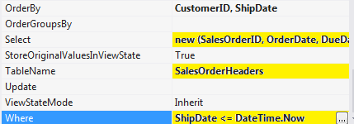

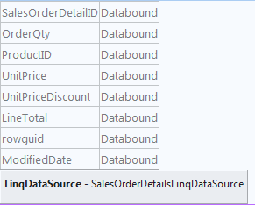

<p>

<asp:DetailsView ID="SalesOrderDetailDetailsView" runat="server" DataSourceID="SalesOrderDetailsLinqDataSource"

Height="50px" Width="125px" AutoGenerateRows="False">

<Fields>

<asp:BoundField DataField="SalesOrderDetailID" HeaderText="SalesOrderDetailID" SortExpression="SalesOrderDetailID" />

<asp:BoundField DataField="OrderQty" HeaderText="OrderQty" SortExpression="OrderQty" />

<asp:BoundField DataField="ProductID" HeaderText="ProductID" SortExpression="ProductID" />

<asp:BoundField DataField="UnitPrice" HeaderText="UnitPrice" SortExpression="UnitPrice" />

<asp:BoundField DataField="UnitPriceDiscount" HeaderText="UnitPriceDiscount" SortExpression="UnitPriceDiscount" />

<asp:BoundField DataField="LineTotal" HeaderText="LineTotal" SortExpression="LineTotal" />

<asp:BoundField DataField="rowguid" HeaderText="rowguid" SortExpression="rowguid" />

<asp:BoundField DataField="ModifiedDate" HeaderText="ModifiedDate" SortExpression="ModifiedDate" />

</Fields>

</asp:DetailsView>

<asp:LinqDataSource ID="SalesOrderDetailsLinqDataSource" runat="server"

ContextTypeName="AdventureWorks.AdventureWorksLT2008"

EntityTypeName="" TableName="SalesOrderDetails"

Where="SalesOrderID == @SalesOrderID">

<WhereParameters>

<asp:ControlParameter

ControlID="SalesOrdersListView"

Name="SalesOrderID"

PropertyName="SelectedValue"

Type="Int32"

DefaultValue="0" />

</WhereParameters>

</asp:LinqDataSource>

</p>

